**Web Applications and AI**



**MSc Computer Science**

**Module Title :** 7051CEM

Web Applications and AI

**Course work Title:** Individual Report

**Educator Name :** Nazaraf Shah

**Student Name:** Prashanth Goud Kairi

**Student Number:** 13401649

**Date of Submission:** 30/11/2023

**CAKE HUB E-SHOP USING JSP TECHNOLOGIES**

Table of Contents

**List of figures** 2

**Web ecommerce development** 3

**Introduction** 3

**UML classes** 3

**System evaluation** 5

**Technologies** 5

**Key features** 5

**Implementation Evidence** 6

**Home page** 6

**Wedding category** 6

**Log in** 7

**Adding one item to cart** 8

**Adding another item to cart** 8

**My cart** 9

**Check out** 9

**Making payment** 10

**Paid successfully** 10

**Admin page** 10

**Successful login** 10

**Adding category** 11

**Adding product** 12

**Database and codes samples** 14

**Sales prediction** 15

**Conclusion** 15

References 16

# **List of figures**

Figure 1: uml class diagram 2

**Figure 2: sequence diagram** 3

Figure 3: homepage 5

Figure 4: Wedding category 5

Figure 5: Logging in as customer 6

Figure 6: Logging in as admin 6

Figure 7: Adding another item to cart 7

Figure 8: cart items 8

Figure 9: Check out 8

Figure 10: Making payment 9

Figure 11: showing successfully successful payment 9

Figure 12" showing Successful admin login 10

Figure 13: Adding category 10

Figure 14: Category added 11

Figure 15: Adding product 11

Figure 16: Product added successfully 12

Figure 17: Added category and product in home page 12

Figure 18: ecommerce database 13

Figure 19: categories 13

Figure 20: codes, running project on tomcat server 13

# **Web ecommerce development**

## **Introduction**

The website is developed for the smooth operation of both the administrator and customer and has various functions depending on the users. The customers can find and select a range of delicious cakes which are neatly categorized. This enables them to browse through different cake categories, view detailed product description, view pictures, price and available discount. Customers choose their cakes then put them in their cart for faster checkout. Moreover, customers who have been registered have the privilege of updating their profiles, viewing past orders, and monitoring current orders. The platform features secure payment options, making it easy and secure for buyers to purchase their favorite cakes.

A robust dashboard with multiple tools is provided for administrators to effectively control the system. They also can develop new cakes, change already existing and classify them appropriately. Additionally, administrators can process customer orders, manage inventory and track sales. As the face of the organization, they can watch over user interaction, answer to questions, and guarantee a nice experience.

## **UML classes**

The class diagram is a fundamental part of an object-modelling approach that establishes a static structure of the system. A single class diagram may be used to map the whole a system or many class diagrams can be employed to represent parts of the system depending the complexity a system.

The purpose of this class diagram is to represent how a particular application views itself dynamically. Class diagrams are the only diagrams that could be directly convertible to the object oriented languages used during development and, thus, commonly used. Class diagram is not that much different from other diagrams like operation diagram which will give only the order of sequencing for the application. The most popular UML in the world (*UML Diagrams for ECommerce*, n.d.).

The current process in the business can be communicated using a sequence diagram by using the business’ staff. A future system implementation can equally be illustrated using diagrams as well. The diagram shows how the objects in a system interact with one another during the design stage (*Blog - Create UML Class Diagrams*, n.d.).

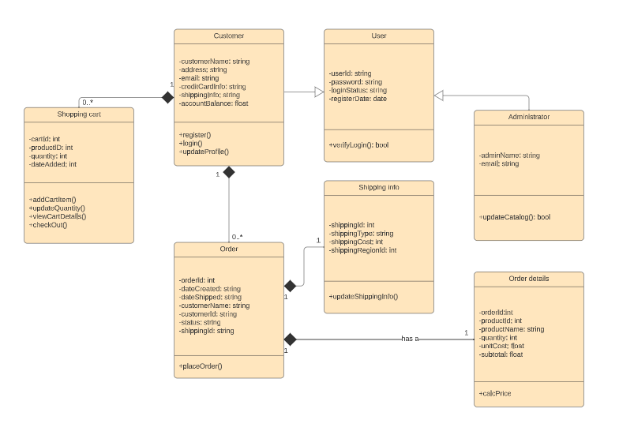

Figure 1: uml class diagram

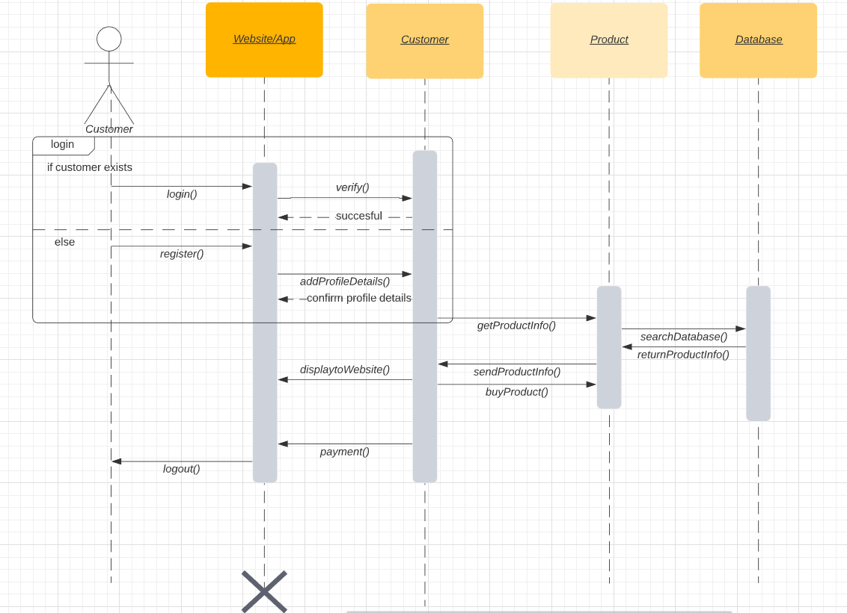

**Figure 2: sequence diagram**

## **System evaluation**

The use of different technological advancements and an organized development environment led to an all-encompassing solution that satisfied both customers and administrators. The application is equipped with numerous features, starting with user-friendly client interfaces and ending with internal administrative tools, all developed according to a JSP-Servlet architecture. Administrators handle products, orders, and customer interactions while customers get to explore, pick and buy the cakes with ease.

### **Technologies**

**JSP and Servlets**: Implemented Leveraged Servlets as controllers which will be used to manage user requests, carry out necessary operations, and interact with both Model and View (JSP) components. With JSP, dynamic web pages were made possible since Java code could be inserted in HTML and served as the base to generate dynamic content according to user actions and server-retrieved data (Flask, n.d.).

**Tomcat server**: Installed the application on Tomcat servlet container running servlets execution, URL mapping and HTTP request handling. That enhanced smooth running of users’ orders and replying.

**MySQL database:** for storing, retrieving, and managing persistent data. Employed JDBC for connecting, and querying with assurance on data consistency and safety.

**HTML/CSS/JavaScript**: HTML supported structure, CSS ensured style, and JavaScript created interaction. These additional technologies complemented the JSP, bringing attractive and responsive visual effects on the user interface.

### **Key features**

* Responsive Design: This platform suits various devices, which makes it run well on laptops, tablets or phones.
* Rich Media Content: For detailed descriptions, product description, and total image of each cake to help customer decision.
* Specialized Categories: Cake classification is not merely by type but by occasions (birthday, wedding, anniversary etc) to help customers find the suitable cake for their event.
* Guest Checkout and Account Creation: Alternatively, clients can opt to proceed to checkout as guests or create an account in order to make future purchases with ease.
* Real-Time Analytics: Admins conduct analytics and reporting to assess what trends are in sales, the most successful cakes, and strategies with customers to be useful for strategy management.
* Order Tracking: This increases the transparency as customers can track their orders from order confirmation to delivery in real time.
* Efficient Fulfillment: Nowadays, the new order processing systems assist managers to process orders, work with bakeries and ensure delivery on time.

## **Implementation Evidence**

## **Home page**

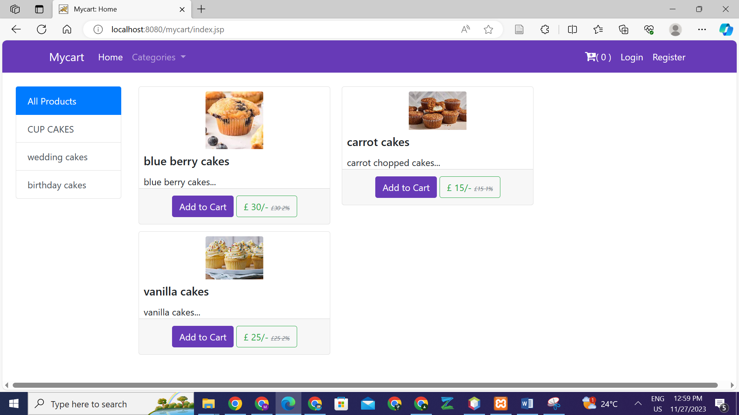

Figure 3: homepage

## **Wedding category**

Wedding category showing no item. These products can be added by admin or in the database.

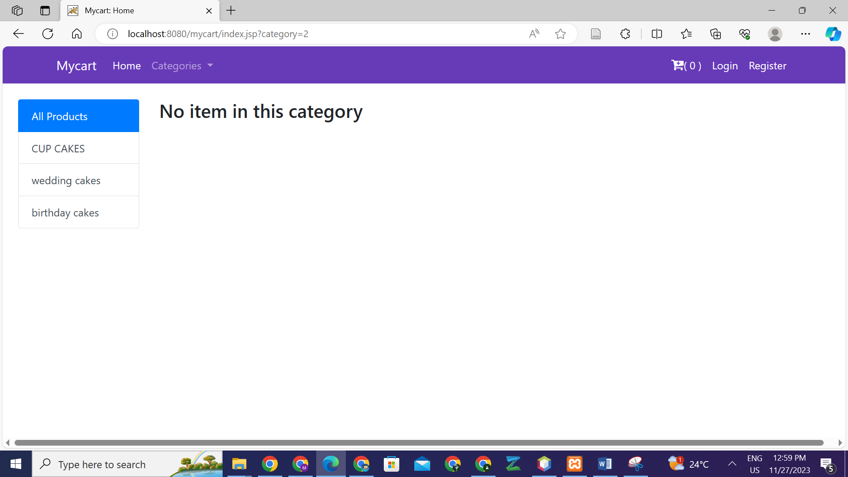

Figure 4: Wedding category

## **Log in**

User can login as either customer or admin. If customer, only the products and carts are visible.

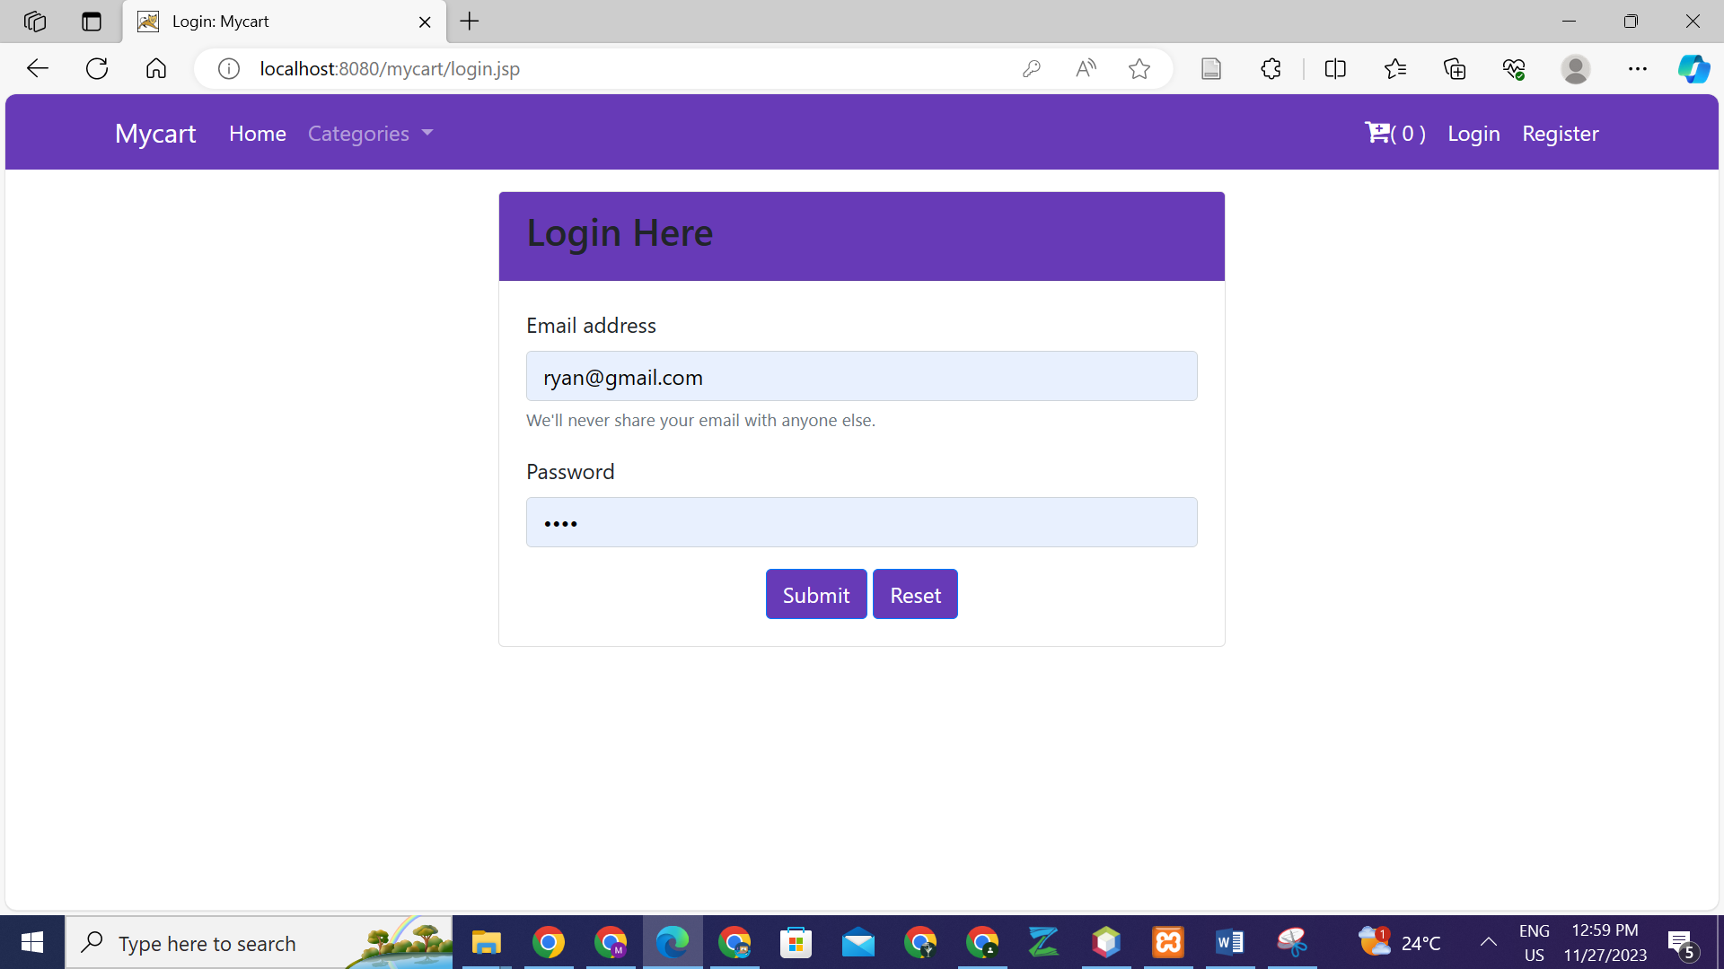

Figure 5: Logging in as customer

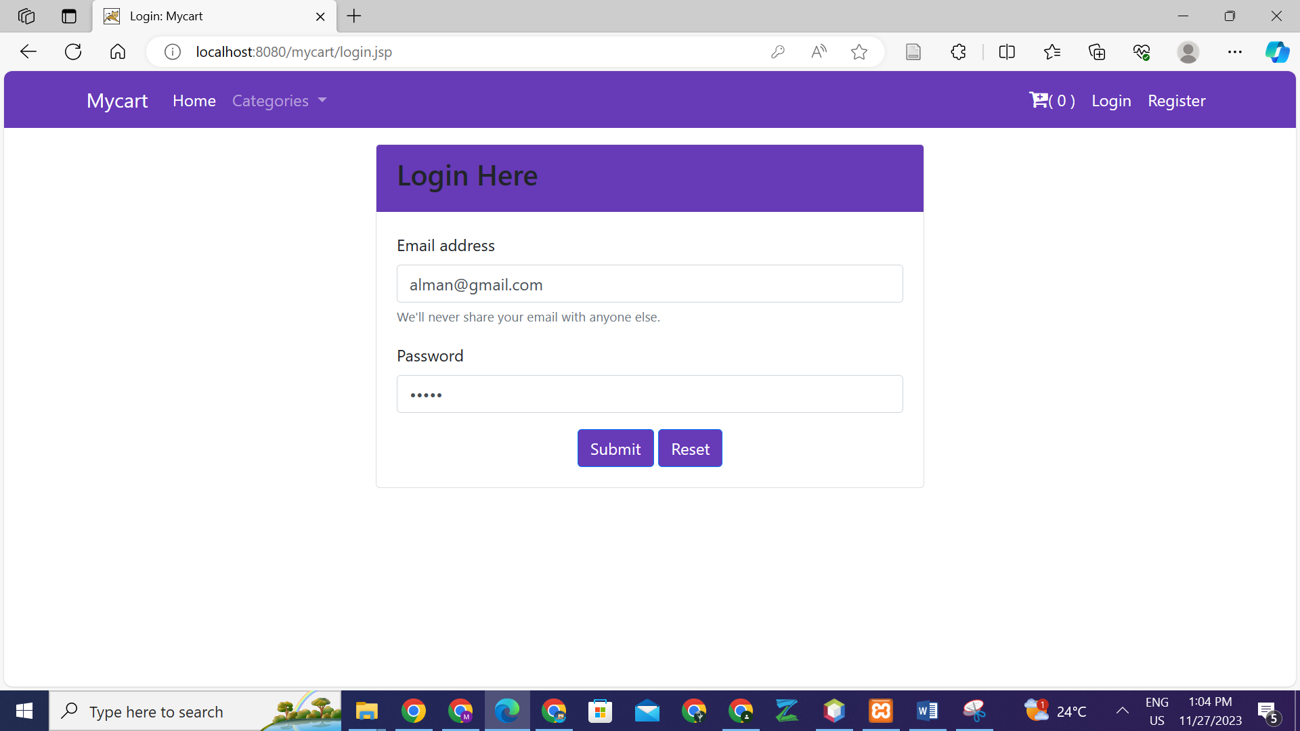

Figure 6: Logging in as admin

## **Adding one item to cart**

The blue berry cakes are added to the cart. By pressing on add to cart two times, the quantity for blue berry cakes increases to two.

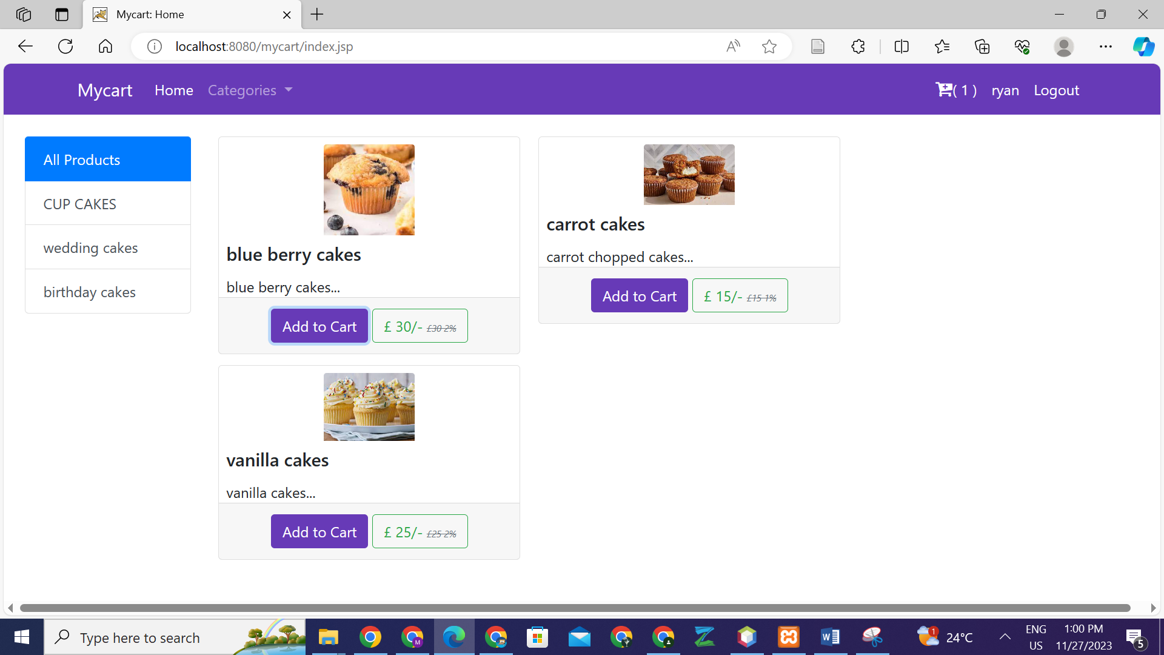

## **Adding another item to cart**

Notice the increment in the cart.

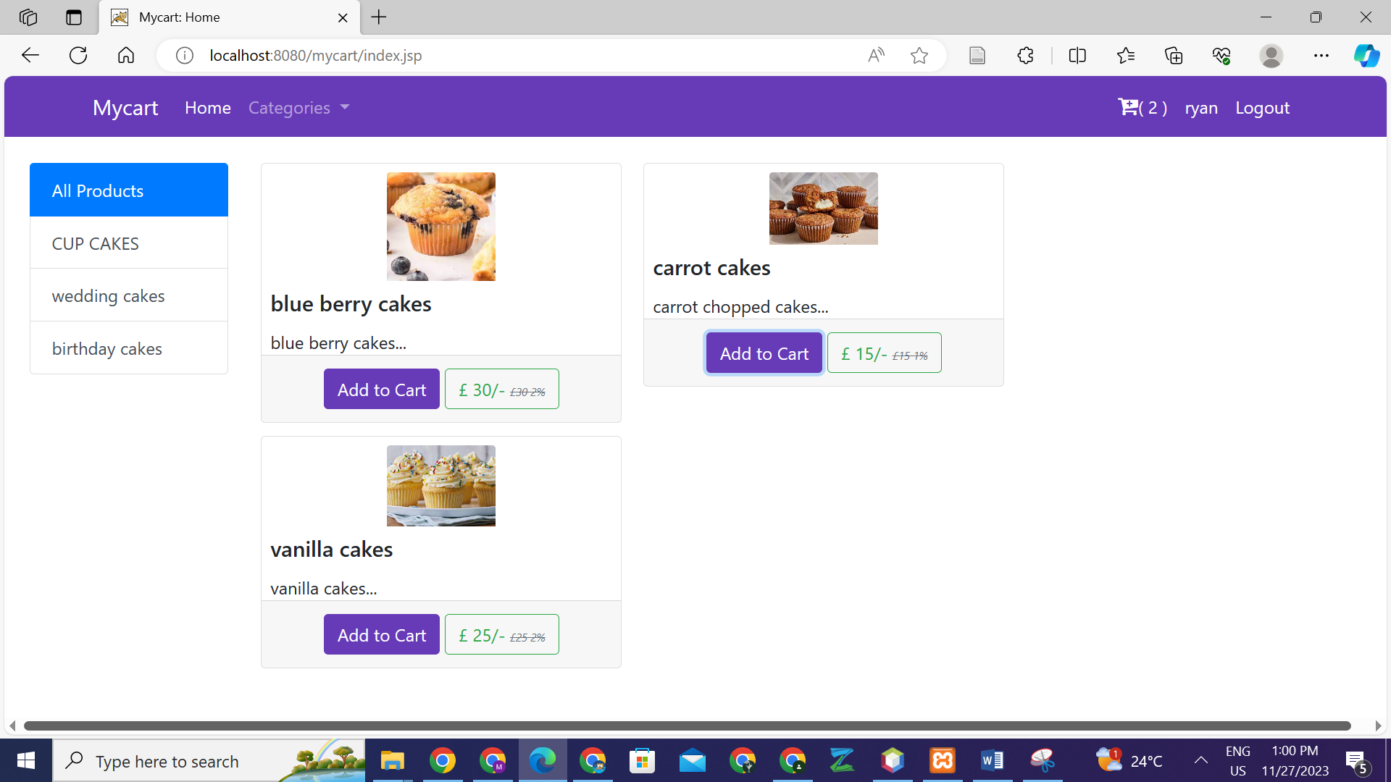

Figure 7: Adding another item to cart

## **My cart**

Showing items in cart, one can also remove items.

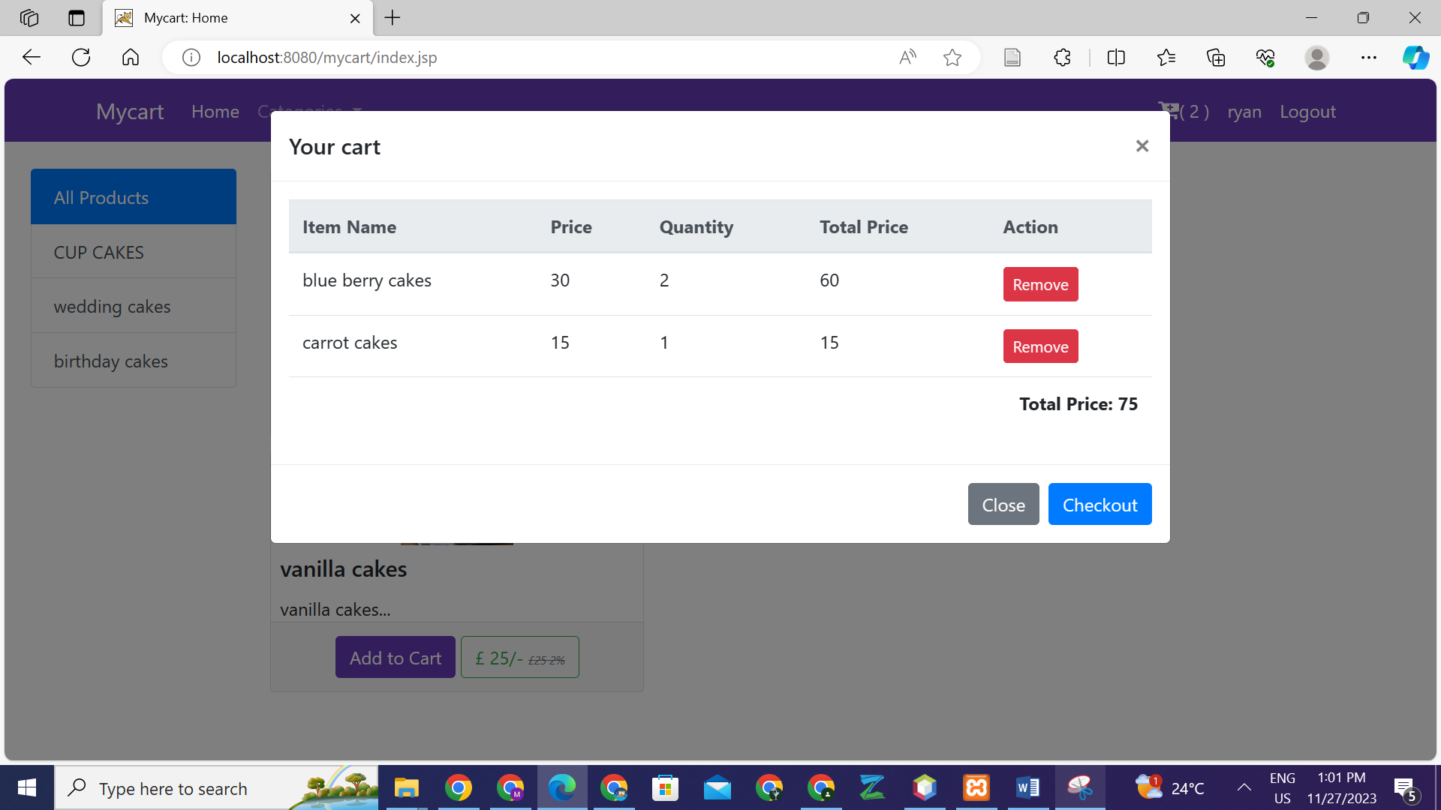

Figure 8: cart items

## **Check out**

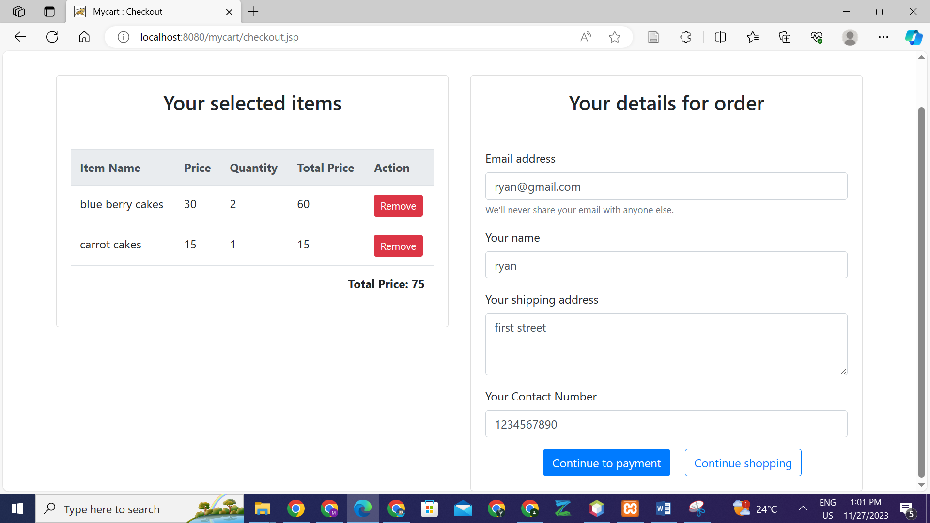

Figure 9: Check out

## **Making payment**

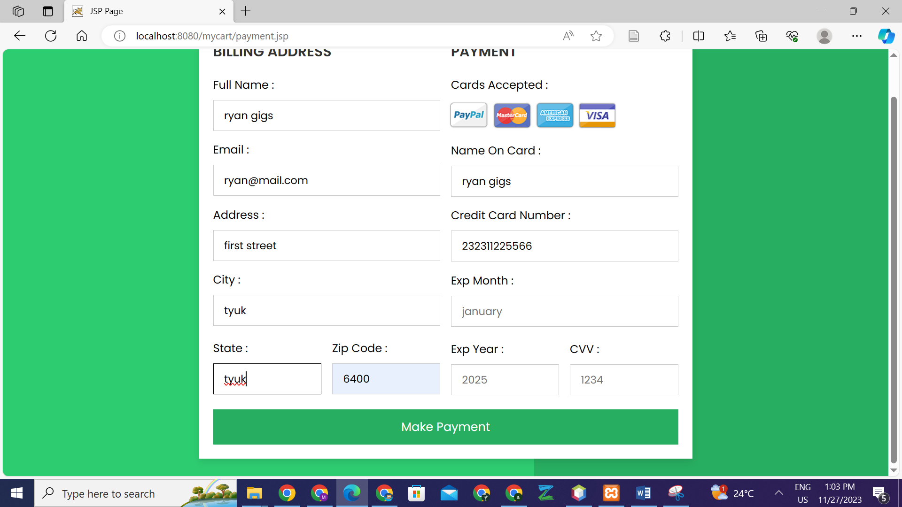

Figure 10: Making payment

## **Paid successfully**

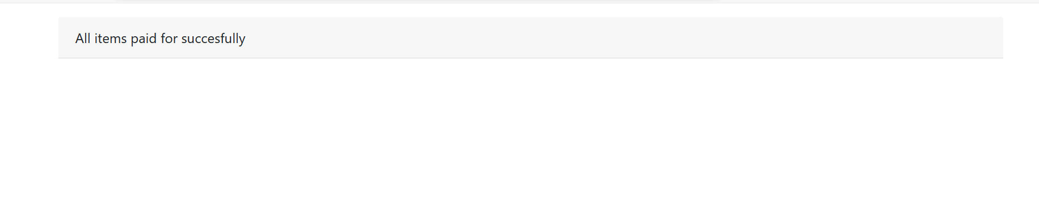

Figure 11: showing successfully successful payment

## **Admin page**

## **Successful login**

The page is different than customers’. The admin dashboard is shown with no of users, categories and products. In addition, it allows the admin to add categories as well as products to the online shop database, which are automatically updated in the e-shop.

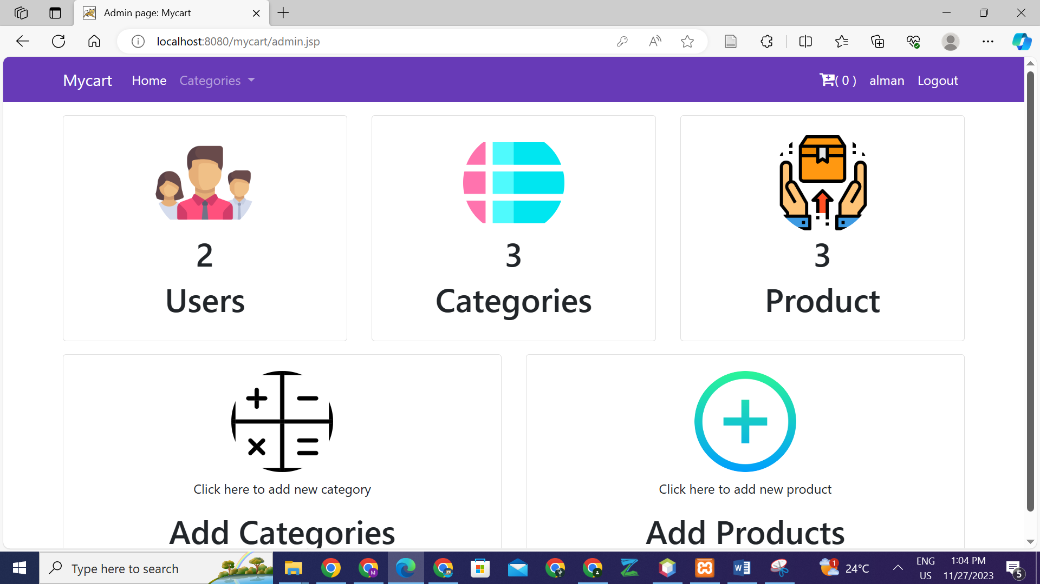

Figure 12" showing Successful admin login

## **Adding category**

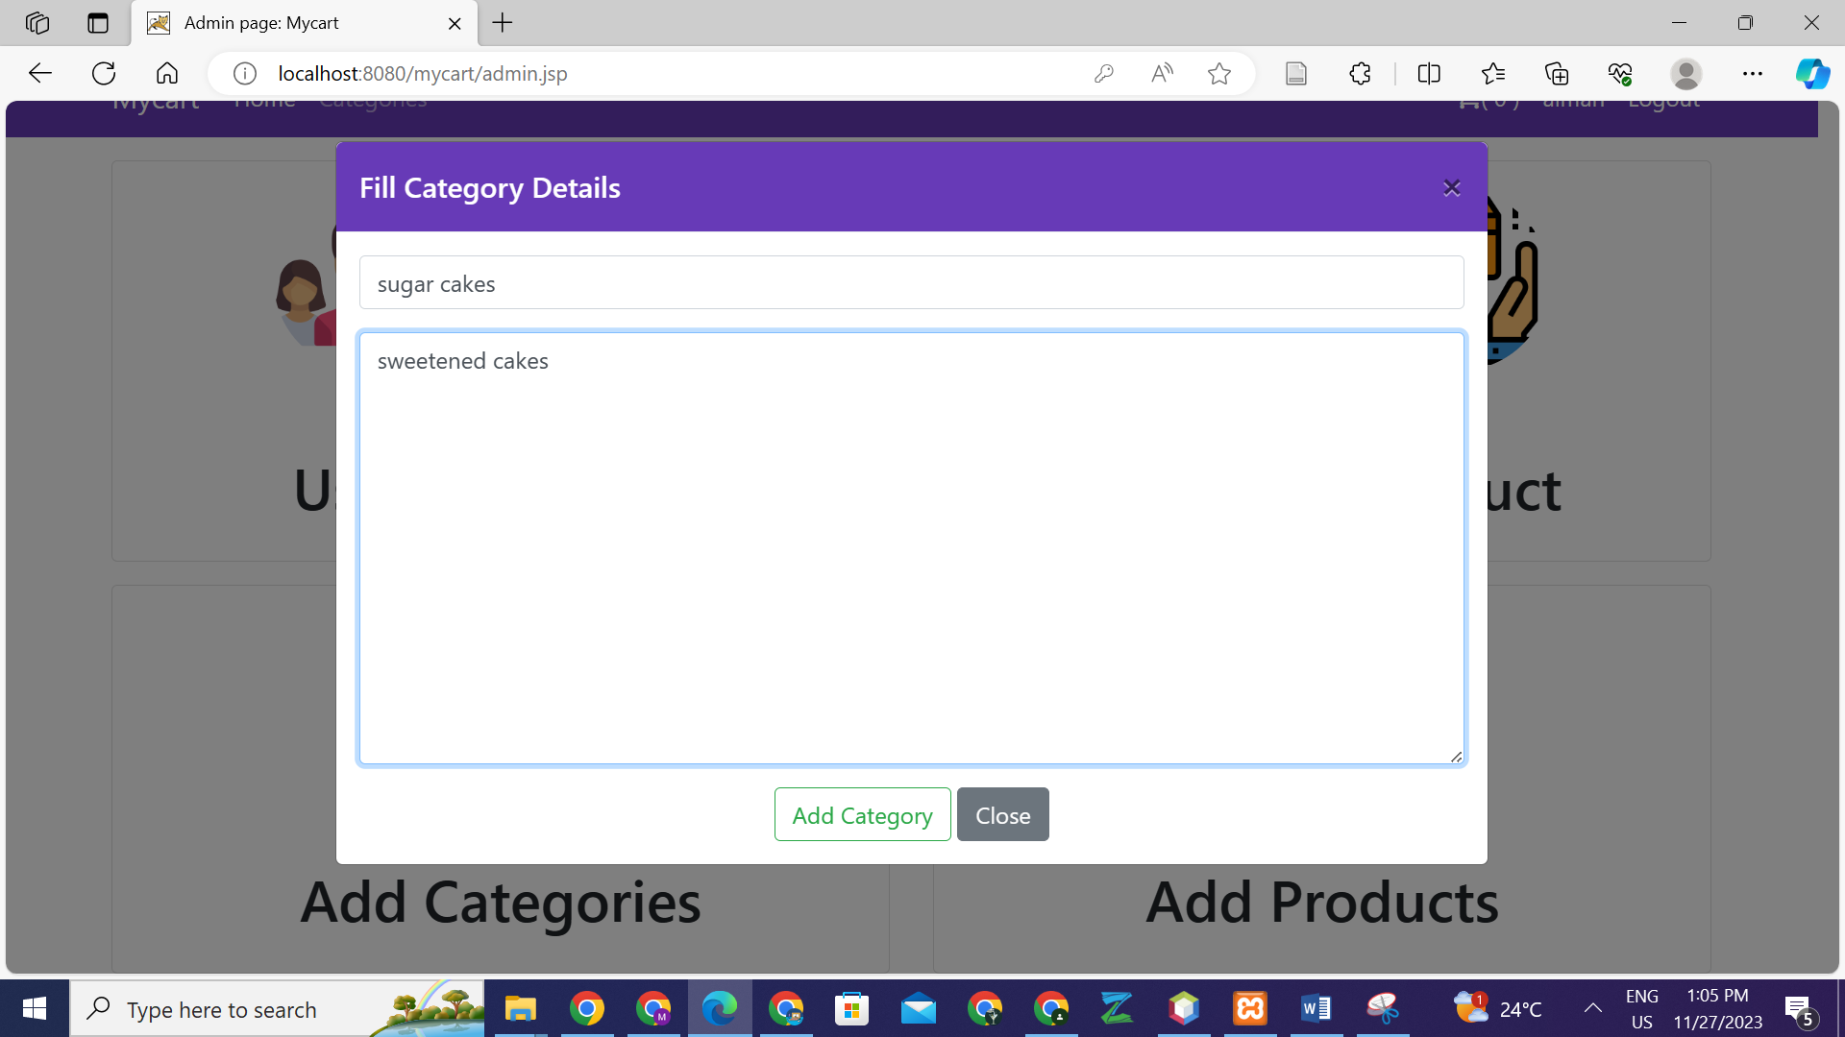

Figure 13: Adding category

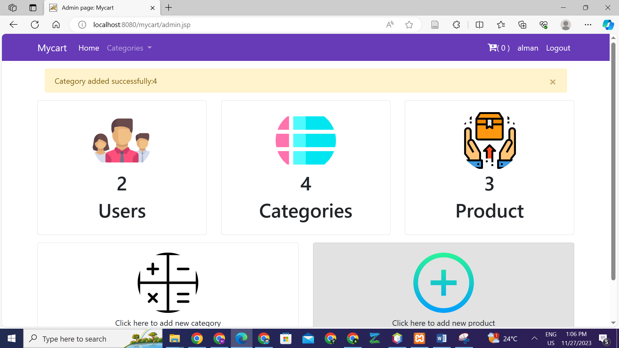

Figure 14: Category added

## **Adding product**

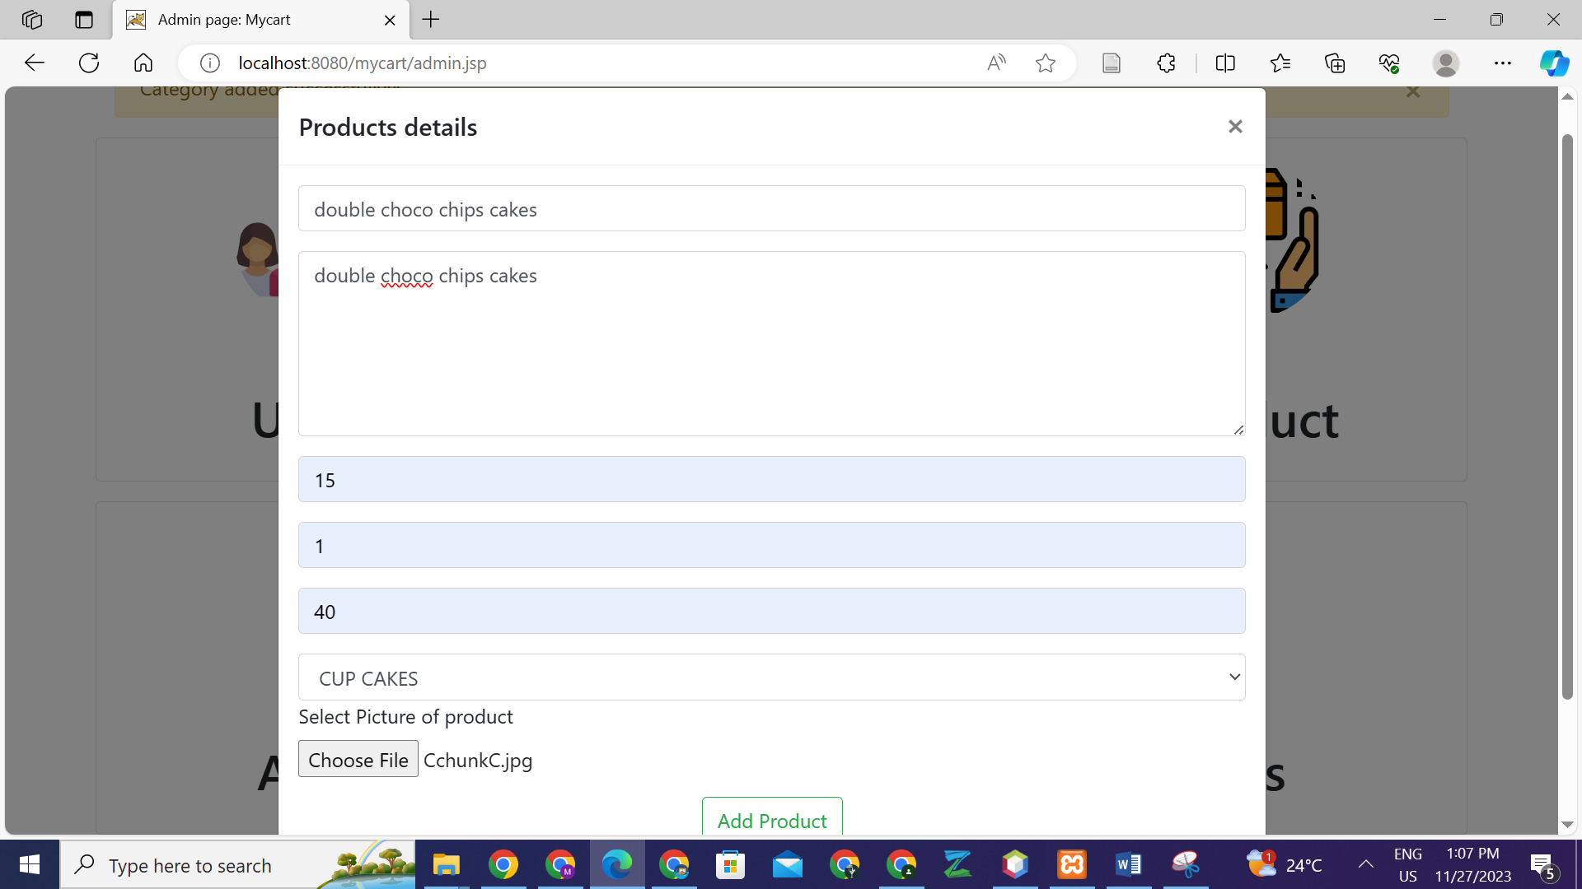

Figure 15: Adding product

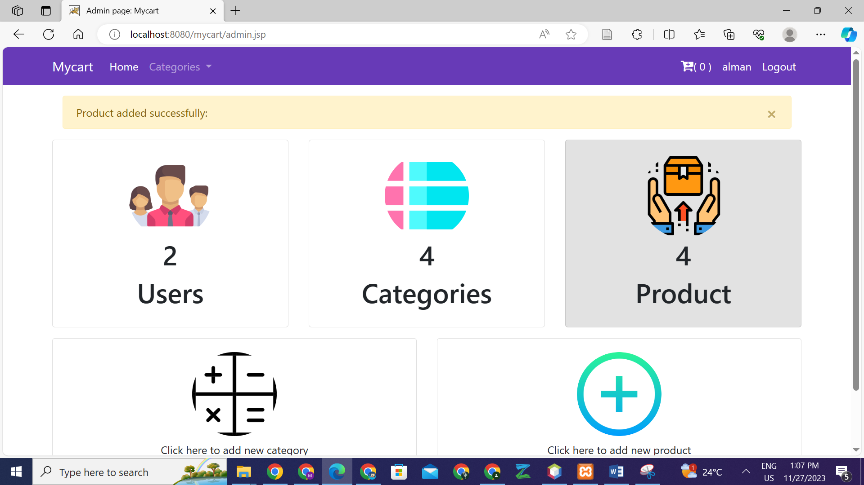

Figure 16: Product added successfully

The figure below shows the added category and product in home page. This shows that the updation was done and reflected on the website as well.

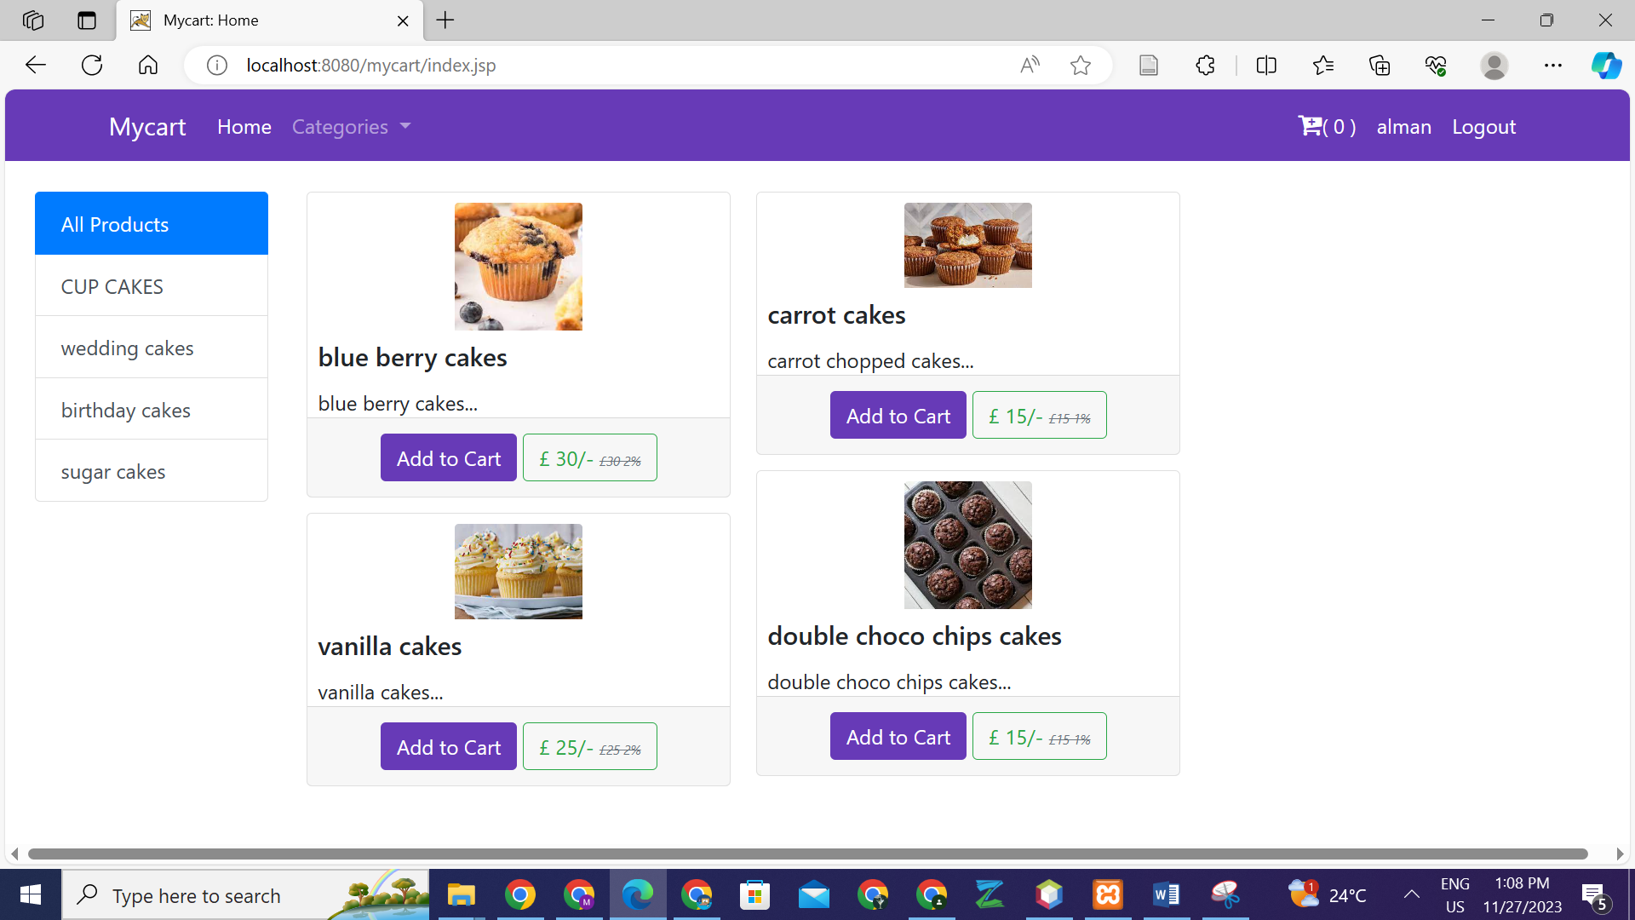

Figure 17: Added category and product in home page

## **Database and codes samples**

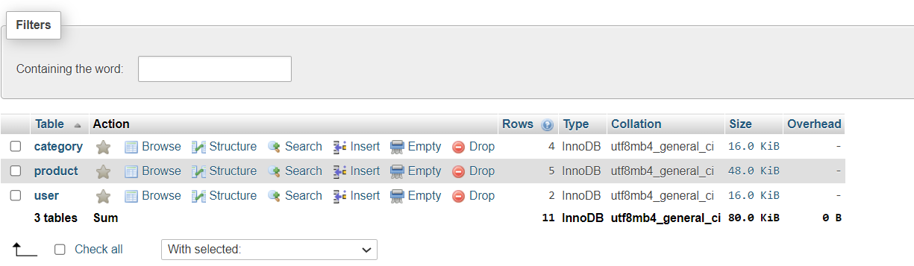

Figure 18: ecommerce database

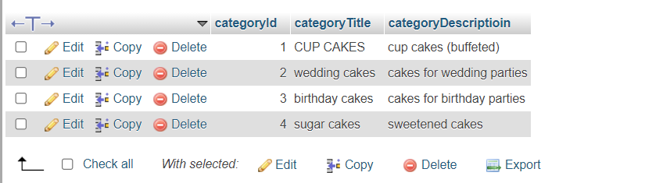

Figure 19: categories

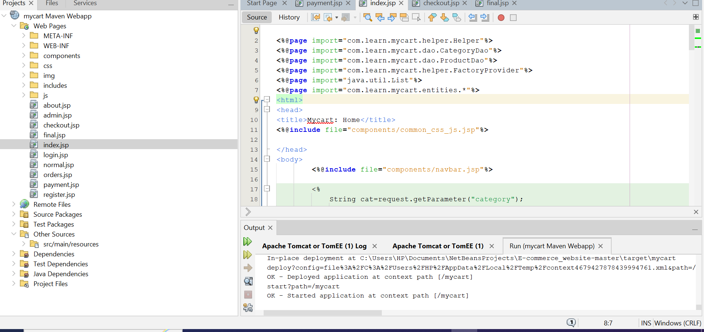

Figure 20: codes, running project on tomcat server

# **Sales prediction**

Many methodologies could help in forecasting sales including linear regression (Pangare et al., 2021). I utilized regression analysis on the aforementioned sales and advertising expenses to estimate the amount of sales in 2023. As a sales forecasting tool, regression analysis enables correlation between advertising and sales costs with resultant estimation of sales based on future budgetary allocations. With Weka’s regression capabilities the historical data can be analyzed with regard to potential sales next year, all things considered, where the extra money allocated for 2023 is added to the advertising budget. Using this approach is beneficial in that it gives a mechanism for predicting sales, which plays a crucial role in planning and decision-making in a business (Babu et al., 2016).

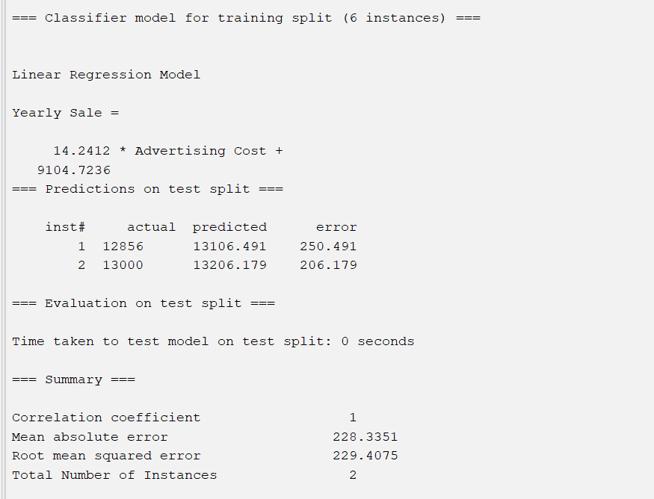

Hence, yearly sale for 2023 is:

14.2412*336 + 9104.7236 = **13889.7668**

# **Conclusion**

The implementation of the Java-based e-commerce platform for cake selling based on jsp and servlets shows a well performed project that fulfills its aims. A technology-based and user-centered site with robust functionalities, scalability capacity, and adequate security measures has been developed, ready for expansion and furtherance into the competitive world of online retailing. The successful application of Java web technologies for making a strong and full-featured Internet shop for selling cakes is one of the proofs of this project.

# References

Babu, S., Ananthanarayanan, N. R., & Ramesh, V. (2016). A Study on Efficiency of Decision Tree and Multi Layer Perceptron to Predict the Customer Churn in Telecommunication using WEKA. *International Journal of Computer Applications*, *140*(4), 26–30. https://doi.org/10.5120/ijca2016909274

*Blog—Create UML class diagrams*. (n.d.). Retrieved November 27, 2023, from https://www.drawio.com/blog/uml-class-diagrams

Flask, R. (n.d.). *JAVA for Beginners*.

Pangare, K., Nimbalkar, S., Pal, R., & Bauskar, R. (2021). *Predict Car Fuel Efficiency Using Linear Regression and add UI*. *08*(05).

*UML diagrams for ECommerce*. (n.d.). GyaaniBuddy. Retrieved November 27, 2023, from https://www.gyaanibuddy.com/assignments/assignment-detail/uml-diagrams-for-ecommerce/